**CHAPTER 1**

**INTRODUCTION**

**Introduction:-**

The concept of this project is to calculate the design parameters required in the construction of a single phase transformer. It is a software based project named XMR, which is developed in Microsoft Visual Studio 2010. It takes few input data and according to that it calculates various design parameters and gives the output.

**Visual Basic** is a [third-generation](http://en.wikipedia.org/wiki/Third-generation_programming_language) [event-driven programming language](http://en.wikipedia.org/wiki/Event-driven_programming) and [integrated development environment](http://en.wikipedia.org/wiki/Integrated_development_environment) (IDE) from [Microsoft](http://en.wikipedia.org/wiki/Microsoft) for its [COM](http://en.wikipedia.org/wiki/Component_Object_Model) programming model first released in 1991. Microsoft intends Visual Basic to be relatively easy to learn and use.Visual Basic was derived from [BASIC](http://en.wikipedia.org/wiki/BASIC) and enables the [rapid application development (RAD)](http://en.wikipedia.org/wiki/Rapid_application_development) of [graphical user interface (GUI)](http://en.wikipedia.org/wiki/Graphical_user_interface) applications, access to [databases](http://en.wikipedia.org/wiki/Database) using [Data Access Objects](http://en.wikipedia.org/wiki/Data_Access_Object), [Remote Data Objects](http://en.wikipedia.org/wiki/Remote_Data_Objects), or [ActiveX Data Objects](http://en.wikipedia.org/wiki/ActiveX_Data_Object), and creation of [ActiveX](http://en.wikipedia.org/wiki/ActiveX) controls and objects.

**Objective:-**

Transformer is one of the important unit in electrical engineering, almost at every stage in power system, transformers are used. Thus, a basic knowledge of its construction, helps in better understanding, and it also provide strong hold over the knowledge of transformer.

**CHAPTER 2**

**IMPLEMENTATION**

**2.1 Modules in project**

1. Parameter I
2. Parameter II
3. Core design
4. Frame design
5. Winding design
6. Results

**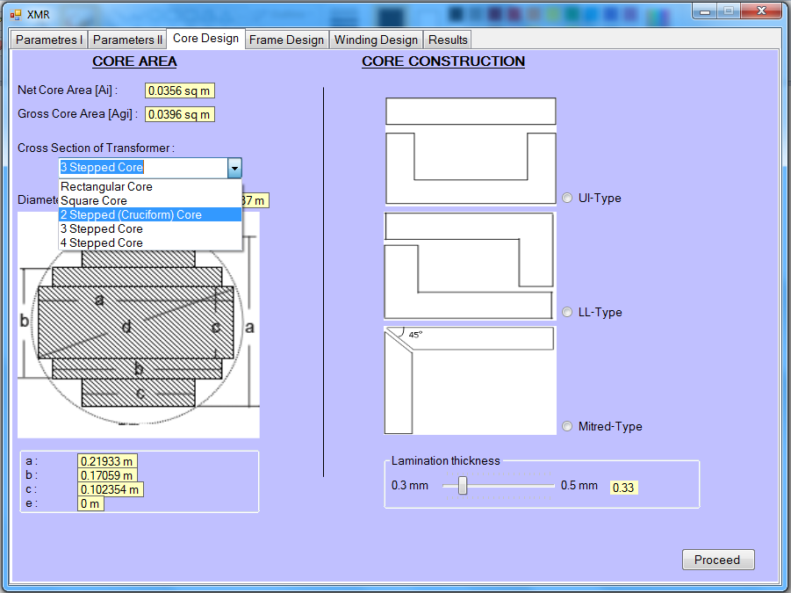**

Fig 1

**2.1.1 Parameter I**

Here we require inputs for designing the transformer these inputs are following:-

1. Transformer rating in KVA( up to 400 KVA)
2. Primary side voltage rating (up to 66 KV)
3. Secondary side voltage rating (up to 66 KV)
4. Temperature in which transformer placed(in degree Celsius)

*Core materials are of 2 types-*

CRGO steel-

Cold rolling is a metal working process in which metal is deformed by passing it through rollers at a temperature below its recrystallization temperature. Cold rolling increases the yield strength and hardness of a metal by introducing defects into the metal's crystal structure. These defects prevent further slip and can reduce the grain size of the metal. Cold rolling is most often used to decrease the thickness of plate and sheet metal. Cold-formed steel members are formed at room temperature; the material becomes harder and stronger. Its lightweight makes it easier and more economical to mass-produce, transport and install.

Hot Rolled steel-

The metallurgical process of Hot rolling, used mainly to produce sheet metal or simple cross sections from billets describes the method of when industrial metal is passed or deformed between a set of work rolls and the temperature of the metal is generally above its recrystallization temperature, as opposed to cold rolling, which takes place below this temperature. Hot rolling permits large deformations of the metal to be achieved with a low number of rolling cycles. The hot-rolled steel shapes are formed at elevated temperatures while the cold-formed steel shapes are formed at room temperature.

*Construction Type-*

Core type

A core-type transformer in the shape of a hollow rectangle having two limbs. It has a single magnetic circuit. The windings surround the core. The coils used are wound and are of cylindrical type having the general form circular, oval or rectangular.

Core-type transformer has a longer mean length of core and a shorter mean length of coil turn. Core has a small cross section of iron; more number of turns is required because the high flux may not reach the core. Core type is used for high-voltage service, since it has sufficient room for insulation.

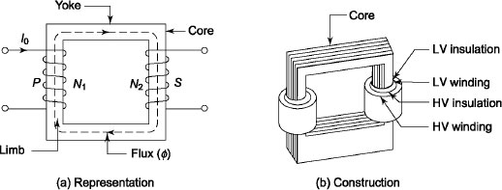

Fig 2

Shell type

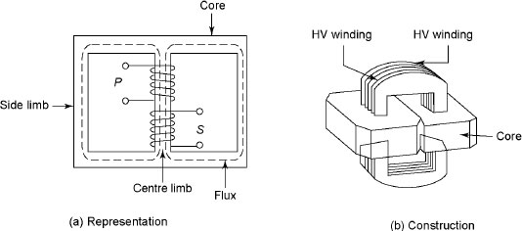Shell-type transformer has double magnetic circuit and three limbs. Both windings are placed on the central limb. The coils occupy the entire space of windows. The coils are usually multi-layer disc type or sandwich coils. The low-voltage coils are placed nearest to the iron core to reduce the

Fig 3

amount of high-voltage insulation. Core is laminated. Special care is taken to arrange the laminations of the core. All the points at alternate layers are staggered properly to avoid narrow air gap at the joint, right through the cross section of the core. The joints are known as *overlapped or imbricate* joints. The shell-type construction is preferred for a few high-voltage transformers. Since the windings are surrounded by core, natural cooling does not exist. To remove any winding during maintenance, removal of a large number of laminations is required. Due to better provision for mechanical support and bracing of coils in the shell-type transformer, better resistance to combat high mechanical force is obtained. High mechanical forces are developed for a high current during short circuit.

*Transformer Type-*

1.Distribution Transformer ( upto 200 KVA) –

A **distribution transformer** is a transformer that provides the final voltage transformation in the electric power distribution system, stepping down the voltage used in the distribution lines to the level used by the customer. The invention of a practical efficient transformer made AC power distribution feasible. Distribution transformers normally have ratings up to 200 kVA,

Since distribution transformer are energized for 24 hours a day (even when they don't carry any load), reducing iron losses has an important role in their design. As they usually don't operate at full load, they are designed to have maximum efficiency at lower loads. To have a better efficiency, voltage regulation in these transformers should be kept minimum. Hence they are designed to have small leakage.

2.Power Transformer ( greater than 200KVA) –

Power transformers are used in transmission network of higher voltages for step-up and step down application and are generally rated above 200KVA. **Power transformer** is used for thetransmission purpose at heavy load, high voltage greater than 33 KV & 100% efficiency. It also having a big in size as compare to distribution transformer, it used in generating station and Transmission substation .high insulation level. **Power Transformers** are used in Transmission network so they do not directly connect to the consumers, so load fluctuations are very less. These are loaded fully during 24 hr’s a day, so Cu losses & Fe losses takes place throughout day the specific weight i.e. (iron weight)/(cu weight) is very less.

a. Voltage per turn-

Et= 4.44*f ϕm* T

b. Flux in core-

*ϕ = Et / (4.44 f T)*

c. Current in primary coil-

Ip = (assume magnetizing current negligible)

d. Current in secondary coil-

Is = Ip\*

e. High Voltage-

Voltage is higher in between primary and secondary voltage

f. Low Voltage-

Voltage is lower in between primary and secondary voltage

**2.1.2 Parameter II –**

Purpose of Transformer Core-

In a electrical power transformer there are primary, secondary and may be tertiary windings. The performance of a transformer mainly depends upon the flux linkages between these windings. For efficient flux linking between these winding one low reluctance magnetic path common to all windings, should be provided in the transformer. This low reluctance magnetic path in transformer is known as **core of transformer**.

Performance of a transformer mainly depends upon the flux linkages between these windings. For efficient flux linking between these winding one low reluctance magnetic path common to all windings, should be provided in the transformer. This low reluctance magnetic path in transformer is known as **core of transformer**.

Maximum Flux Density [Bm]:-

Let us consider, the diameter of **transformer core** be ′D′

http://www.electrical4u.com/equations/tc1.gif

Now, voltage per turn

E = 4.44.φm.f

= 4.44.A.Bm.f

Where Bm is the maximum flux density of the core.

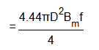

E is proportional to D2

Therefore voltage per turn is increased with increase in diameter of transformer core  
Again if voltage across the winding of transformer is V

**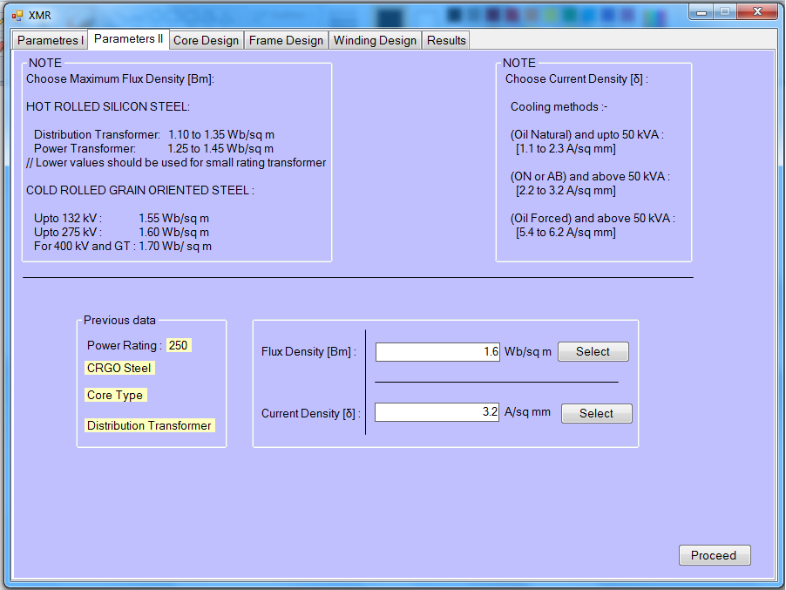**

fig 4

In Hot rolled silicon steel

1. For distribution transformer 1.10 to 1.35 Wb/sq m
2. For power transformer 1.25 to 1.45 Wb/sq m

\*Lower values should be used for small rating transformer

In cold rolled grain oriented steel

1. Up to 132 KV – 1.55 Wb/sq m
2. Up to 275 KV- 1.60 Wb/sq m
3. For 400 KV and above – 1.70 Wb/sq m

Current Density: -

Current density is the electric current per unit area of cross section. Current density is denoted by *J* and unit is A/m2.

Its magnitude is given by the limit

J = \lim\limits_{A \rightarrow 0}\frac{I(A)}{A}

Where

I = electric current (SI unit: A)

*A* =per unit area (SI unit: m2).

current density in the winding is depends upon the cooling method of the transformer which is used.

## Cooling of transformer-

Transformer is a static device that converts one voltage level to another voltage level. Due to occurrence of iron and copper losses, the transformer gets heated. In order to avoid deterioration of insulation, dissipation of heat is required to keep the temperature of the winding within a limited value. Since transformer is a static device, its cooling is more difficult than that of a rotating machine.

The cooling methods used in transformers up to 25 kVA size and of dry type are discussed below:

* *Natural air:* Ambient air is used as the cooling medium in this method, and the natural circulation of surrounding air is used to carry away the generated heat by natural convection.
* *Air blast:* Natural circulation of air used in cooling becomes insufficient for dissipation of heat from large transformers. Therefore, circulation of air (air blast) is used to keep the temperature rise within prescribed limits.
* *Oil-immersed self-cooled transformers:* The transformer is immersed in oil. The heat generated in cores and windings is passed to the oil by conduction. Therefore, oil in contact with the heated parts rises and cool oil takes its place. The heat is transferred to the tank walls by natural oils

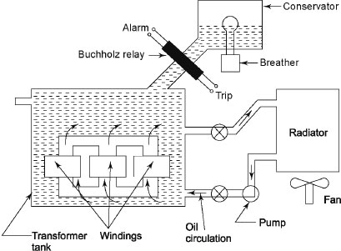

Fig 5 Air Blast Cooling for High-capacity Transformer

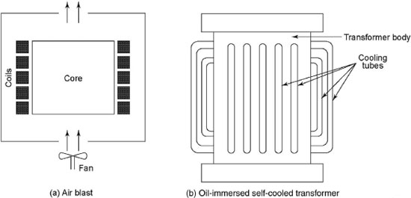

Fig 6 Blast and Oil-immersed Self-cooled Transformer

Finally, ambient air takes this heat. To increase the heat dissipating capacity, corrugations, fins, tubes and radiators are to be provided in Figure.

*Oil-immersed forced air-cooled transformers:* In this method, air is directed over the outer surfaces of the tank of the transformer immersed in oil.

* *Oil-immersed water-cooled transformers:* In this type of cooling, water is pumped through a metallic coil immersed in the oil just below the top of the tank to extract heat from the oil. The heated water is cooled in a spray pond or a cooling tower.
* *Oil-immersed forced oil-cooled transformers:* To extract heat from the oil, oil itself is pumped upwards through the winding. Then it is sent back by way of external radiators. These radiators are cooled by fans. The extra cost of pumping equipment should be justified economically. The main advantage is the reduction in temperature difference between the top and the bottom of the enclosing tank. Figure shows the schematic arrangement of air blast cooling used for high-capacity transformers.

Methods of Cooling of Transformers

|  |  |  |
| --- | --- | --- |
| s.no. | Cooling type | Transformer rating |
| 1. | Natural radiations | Transformers having low voltage and output rating |
| 2 | Oil filled and self cooled | Large sized transformers with ratings up to 132 kV and100 MVA |
| 3 | Forced cooling with air blast | Machines with ratings higher than 33kV and 100 MVA |
| 4 | Oil forced water cooled | Medium sized transformers, cooling is similar to neutral radiations except water cooling |

Current densities are according to the cooling method.

1. for oil natural and up to 50 kVA - [1.1 to 2.3 A/sq mm]
2. for oil natural or air blast and above 50kVA - [2.2 to 3.2 A/sq mm]
3. for oil forced or above 50kVA – [5.4 to 6.2 A/sq mm]

**2.1.3 Core Design:**

(1) For 1-phase core type transformer

Rating is given by

Q =  KVA

=  KVA 

=  KVA ----------- (1) 

Where

L

V

L

V

L

V

L

V

H

V

H

V

H

V

H

V

1-phase core type transformer with concentric windings

Fig 7

Window

f = frequency

= Maximum flux in the core

 = Sectional area of core

= Maximum flux density in the core

Fig 7

Window Space Factor











So



Put equation value of N1I1 form equation (2) to equation (1)





1-phase shell type transformer with sandwich windings

LV

HV

LV

HV

LV

LV

HV

LV

HV

LV

Window

(2) For 1- phase shell type transformer

Window Space Factor

Kw



 fig 8



So



Put equation value of N1I1 form equation (4) to equation (1)





Note it is same as for 1-phase core type transformer i.e. equ (3)

**Core Construction:**

(b) E-I type

(a) U-I type

(c) U-T type

(d) L-L type

(e) Mitered Core Construction (Latest)

45o

Fig 9

**Different cross section of transformer: -**

**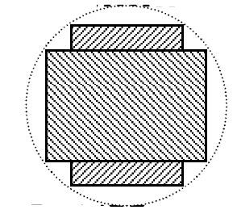**

For 2 Stepped (Cruciform) Core

**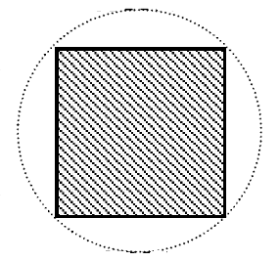**

For Square Core Type

**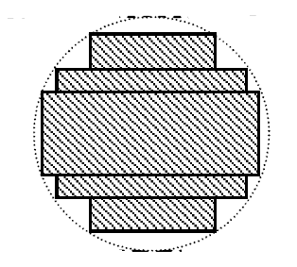**

For 3 stepped core

**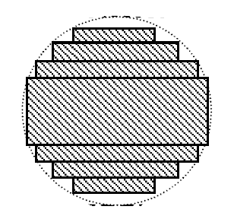**

For 4 Stepped Core

Fig 10

|  |  |  |  |  |  |  |  |  |  |
| --- | --- | --- | --- | --- | --- | --- | --- | --- | --- |
| No of steps | 1 | 2 | 3 | 4 | 5 | 6 | 7 | 9 | 11 |
| % Fill | 63.7% | 79.2% | 84.9% | 88.5% | 90.8% | 92.3% | 93.4% | 94.8% | 95.8% |

**2.1.4 Frame design:**

Window space factor = Kw = 10/(30+KV)

(for 50-200 kVA)

Window space factor = Kw = 12/(30+KV)

(for 1000 kVA)

Window space factor = Kw = 8/(30+KV)

(for 20 kVA)

Area of window **= $Aw=\frac{total conductor area}{window space factor}$**

$Aw$ = height of window(Hw) \* width of window(Ww)

Hw / Ww ~= 2 to 4

D= width of iron + width of bare conductor + width of iwidth of insulation & clearance

Diameter of circumcribingcircle for

Square core –

d=√ Ai / 0.45

2 stepped or cruciform

d=√ Ai / 0.56

3 stepped

d=√ Ai / 0.6

4 stepped

d=√ Ai / 0.62

In shell type it takes only rectangular core section

In core type Square core, 2 stepped or cruciform, 3 stepped, 4 stepped

**2.1.5 Winding design:**

Windings are usually made of high grade of copper. Standard conductors are used for carrying higher current. To avoid the each turn to come in contact with each other, the windings are provided with insulation. In addition to inter-turn insulator, bare copper wires are provided with enamel coating. Usually single- or double-layer cotton is used. Sometimes press board or cotton insulation is also used to support the windings. Usually additional insulation is provided for line end turns for their protection from lightning and switching over voltages. During transient disturbances, the distribution of voltage is not uniform along the windings and 80 per cent of voltage at that time appears across the first 10 per cent of turns from line end. The ratio of heat generated to heat dissipated is approximately proportional to the ratio of volume of the material for conductors and the core to the surface area of the material for conductors, the core and the tank, which must approach to unity to limit the temperature rise.

The following are the most important requirements of transformer windings:

* The windings must be economical.
* The heating conditions of the windings should satisfy standard requirements.
* The windings must have good mechanical strength to combat the force that originates due to short circuit.
* The windings must have the necessary electrical strength during over-voltage. The following are the two different types of windings: (i) Concentric windings and (ii) sandwich windings.

### *Concentric Windings*

Figure 11 shows concentric windings, which are used for core-type transformers.

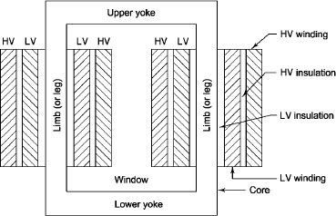

Fig 11- Concentric Windings

Concentric windings are classified into four following groups:

(i) Spiral windings.

(ii) Helical windings.

(iii) Cross-over windings.

(iv) Continuous disc windings.

These windings are discussed as follows.

#### Spiral Windings

These coils are suitable for windings to carry high currents, which are generally used or currents greater than 100 A. They are almost used for LV windings. Figure 12 shows double-layer spiral coils, which are wound on solid insulating former, and hence are mechanically strong.

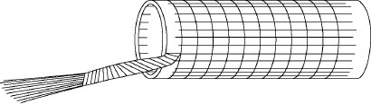

Fig 12 -Double-layer Spiral Coil

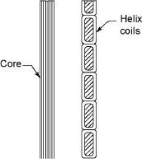

Fig 13- Helical Coils

#### Helical Windings

These coils are wound in the form of helix, which are generally used for low voltages 11 kV to 33 kV for large transformers. Figure 13 shows the cross-sectional view of helical coils where each conductor consists of a number of rectangular strips wound in parallel radially.

#### Cross-over Windings

These coils are generally wound on formers. Each coil consists of several layers and each layer consists of several turns. Figure 14 shows cross-over coils. The conductors may be of round wire with paper or cotton insulation and not suitable for currents exceeding 20 A. These coils are generally used for small transformers and for HV windings.

#### Continuous Disc Windings

Figure 14 shows disc coils. These windings consist of a number of disc and each disc consists of number of turns wound radially over one another from inside outwards and outside inwards alternately. Conductor consists of single number of rectangular strips and passes continuously from disc to disc for multiple strip of conductors. The transposition of conductors is done to ensure uniform current distribution. These are used for HV windings of large power transformers.

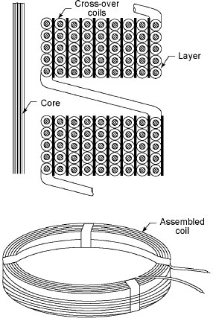

Fig 14-Cross-over Coil

**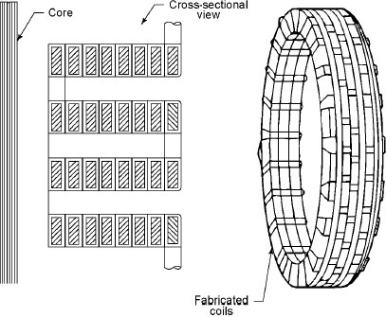**

Fig 15**-**  Disc Coils

### *Sandwich Windings*

Figure 15 shows sandwich windings used in shell-type transformers. The high-voltage and low-voltage windings are split into a number of sections where each high-voltage section lies between two low-voltage sections. In sandwich coils, easily leakage can be controlled. Desired value of leakage reactance can be obtained by proper division of windings.

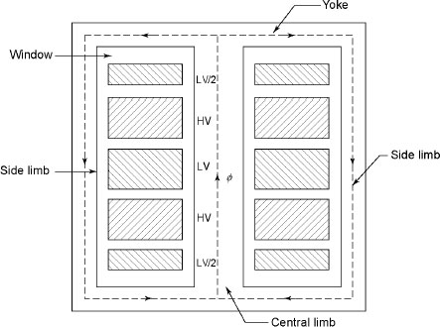

Fig 16 -Sandwich Windings

**2.1.6 Results:**

By example-

1. Transformer rating in KVA( up to 400 KVA)= 400 KVA
2. Primary side voltage rating (up to 66 KV)= 33 KV
3. Secondary side voltage rating (up to 66 KV)= 11KV
4. 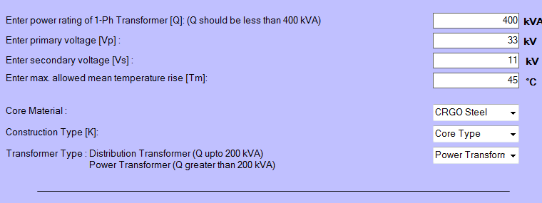Temperature in which transformer placed(in degree Celsius) = 45

**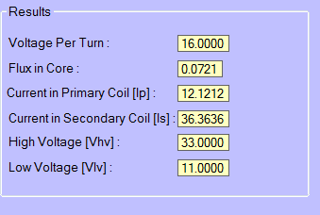**

**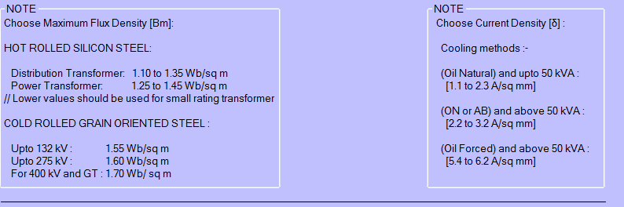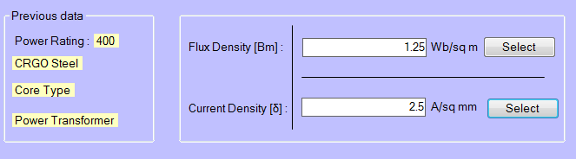**

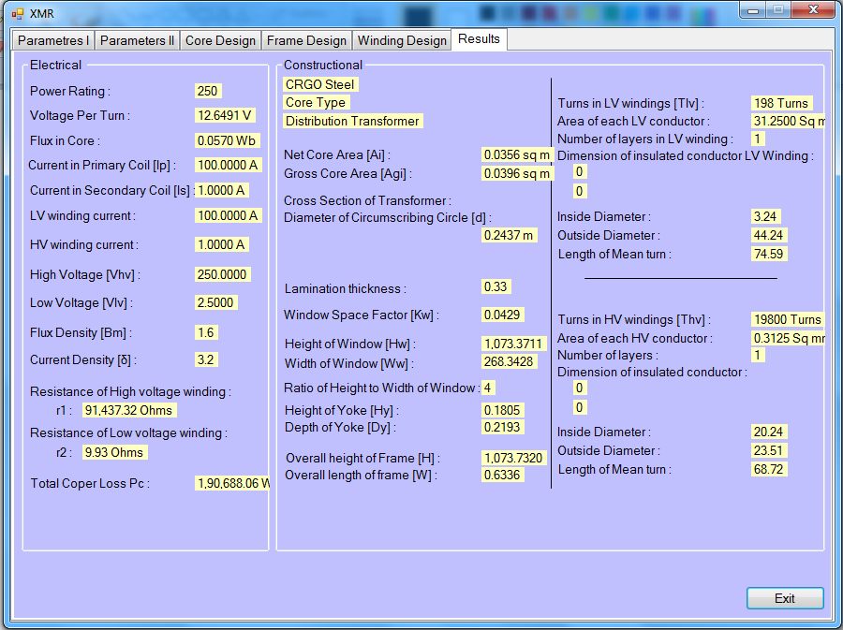

Fig 17

**CHAPTER 4**

**FUTURE SCOPE & CONCLUSION**

**Future Scope of Software Technology:** if the software technology like Microsoft visual basic is used for software designing of single phase transformer or three phase transformer design we can reduce a lot of efforts in the field of industrial application for calculations of various parameters without any efforts. if this software designing technology is implemented in a wide scale we can implement many industrial applications in the field of electrical, mechanical, civil or in other field.

**SOFTWARE SCOPE:**

* **Extensibility**: This software is extendable in ways that its original developers may not expect. The following principles enhances extensibility like hide data structure, avoid traversing multiple links or methods, avoid case statements on object type and distinguish public and private operations.
* **Reusability**: Reusability is possible as and when require in this application. We can update it next version. Reusable software reduces design, coding and testing cost by amortizing effort over several designs. Reducing the amount of code also simplifies understanding, which increases the likelihood that the code is correct. We follow up both types of reusability: Sharing of newly written code within a project and reuse of previously written code on new projects.
* **Understandability:** A method is understandable if someone other than the creator of the method can understand the code (as well as the creator after a time lapse). We use the method, which small and coherent helps to accomplish this.
* **Cost-effectiveness:** Its cost is under the budget and make within given time period. It is desirable to aim for a system with a minimum cost subject to the condition that it must satisfy the entire requirement.
* **Scope:** Scope of this document is to put down the requirements, clearly identifying the information needed by the user, the source of the information and outputs expected from the system.

**REFERENCES**

[1]

http://electrical-engineering-portal.com/difference-between-power-transformer-and-distribution-transformer

[2]

<http://www.electrical4u.com/core-of-transformer-and-design-of-transformer-core/>

[3]

http://www.alstom.com/grid/products-and-services/high-voltage-power-products/electrical-power-transformers/

[4]

http://www.electricityforum.com/products/trans-s.htm

[5]

http://www.thomasnet.com/articles/electrical-power-generation/transformer-types

[6]

http://www.trafoworld.com/en/transformers/different\_types\_transformer/

[7]

<http://en.wikibooks.org/wiki/Electronics/Transformer_Design>